**BRIEF PROFILE ( SMT. SUNITA GANESH JOSHI)**

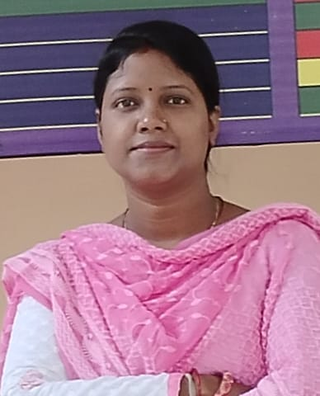

**Name: SMT. SUNITA GANESH JOSHI**

**Designation: ASSISTANT PROFESSOR (COMMERCE)**

**Department: DEPARTMENT OF COMMERCE**

**College Name: GOVT. GHANSHYAM SINGH POST**

**GRADUATE COLLEGE BALOD**

**­Dateof Birth: 25/08/1986**

**Dateof first Appointment: 25/09/2017**

**Dateof Regularization: 25/09/2019**

**SpecializationinP.G.: FINANCE**

**Qualification Detail:**

|  |  |  |  |  |
| --- | --- | --- | --- | --- |
| **S.No.** | **Qualification Name** | **Institution Name** | **Board/University** | **YEAR** |
| 1 | CG SET 2013 |  |  | 2014 |
| 2 | M. COM. (FINANCE) | GOVT. RAMANUJ PRATAP SINGH DEV P.G. COLLEGE BAIKUNTHPUR, DIST.- KOREA (C.G.) | SARGUJA UNIVERSITY AMBIKAPUR (C.G) | 2011 |
| 3 | B. COM (FINANCE) | ST. THOMAS COLLEGE RUABANDHA, BHILAI , DIST.- DURG (C.G.) | PT. RAVISHANKAR SHUKLA UNIVERSITY , RAIPUR (C.G) | 2008 |
| 4 | 12 TH (COMMERCE) | D.A.V. PUBLIC SCHOOL BISHRAMPUR , DIST.- SARGUJA (C.G.) | CBSE | 2005 |
| 5 | 10 TH | CARMEL CONVENT ENGLISH MEDIUM SCHOOL BISHRAMPUR, DIST.- SARGUJA (C.G) | CGBSE | 2003 |

**Residential Address BUDHAPARA, BALOD (C.G)**

**Telephone No./ Mobile +91 7746914224**

**E-mail Address smtsunitajoshi@gmail.com**

**Teaching Experience U.G. 08Years**

**Teaching Experience P.G. 03 Years**

# Attended Refresher/ Orientation/ FDP :

|  |  |  |  |  |
| --- | --- | --- | --- | --- |
| **S.No.** | **Program Name** | **Day/Week/Month** | **Organized by** | **Date** |
| **1** | FIP (GURUDAKSHA) | 01 MONTH | **HRDC, PT. RAVISHANKAR SHUKLA UNIVERSITY , RAIPUR (C.G)** | **12/01/2022 TO 17/02/2022** |
| **2** | REFRESHER COURSE IN COMMERCE AND FINANCIAL MANAGEMENT | 15 DAY’S | **HRDC, JAI NARAIN VYAS UNIVERSITY, JODHPUR, RAJASTHAN** | **11/09/2023 TO 24/09/2023** |

**Responsibilities:**

1. Carrier Counseling and Placement CellCoordinator
2. In-Chargeof A.Q.A.R. Criteria 5.
3. Memberof Discipline Committee
4. MemberofGrievances RedressalCell ofCollege.
5. Memberof Anti Ragging CommitteeofCollege.
6. MemberofCommitteeof Cultural Literary and Youth Festival.
7. Member of St/Sc Committee
8. Member of Female Common Room
9. Member of Sports Committee.